A good data story brings data and facts to life. Use this article for tips on best practices to use with Tableau's story points feature.

The seven types of data stories
When you use the story feature, you are building a sequence of points. Each point can contain a view, dashboard, or even just text. Some stories show the same view throughout the story, with text annotations and different filters applied to different points to support the narrative arc.
The following table describes seven different data story approaches you can take and provides an example for each. Each data story type is also illustrated in the Data Story Examples Workbook(Link opens in a new window) on Tableau Public. A single story can also use more than one approach—see Example - A Story That Examines a Trend.
Data Story Type | Description
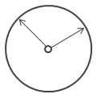  Change Over Time | What it does: Uses a chronology to illustrate a trend.  Discussions it starts: Why did this happen, or why does it keep happening? What can we do prevent or make this happen?  Example: Arsenal's Injury Crisis(Link opens in a new window)
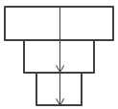  Drill Down | What it does: Sets context so that your audience better understands what's going on in a particular category.  Discussions it starts: Why is this person, place or thing different? How does the performance of this person, place, or thing compare?  Examples: Tell Me About Will(Link opens in a new window), The Simpsons Vizipedia(Link opens in a new window)
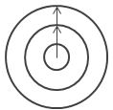  Zoom Out | What it does: Describes how something your audience cares about relates to the bigger picture.  Discussion it starts: How does something you care about compare to the bigger picture? What effect does one area have on the bigger picture?  Example: Vancouver Cyclists(Link opens in a new window)
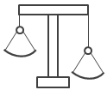  Contrast | What it does: Shows how two or more subjects differ.  Discussions it starts: Why are these items different? How can we make A perform like B? Which area should we focus on and which area is doing fine?  Example: The Pyramids of Egypt(Link opens in a new window)
  Intersections | What it does: Highlights important shifts when one category overtakes another.  Discussions it starts: What causes these shifts? Are these shifts good or bad? How do these shifts affect other aspects of our plan?  Example: US vs. THEM(Link opens in a new window)
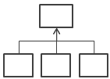  Factors | What it does: Explains a subject by dividing it into types or categories.  Discussions it starts: Is there a particular category we should focus on more? How much do these items affect the metric we care about?  Example: Planet Earth(Link opens in a new window)
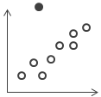  Outliers | What it does: Shows anomalies or where things are exceptionally different.  Discussions it starts: Why is this item different?  Example: SOS Children's Villages(Link opens in a new window)

